10.73: Find the speed v the marble needs at the edge of the pit to make it to the level ground on the other side. The marble must travel 36 m horizontally while falling vertically 20 m.
Use the vertical motion to find the time. Take 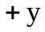to be downward.
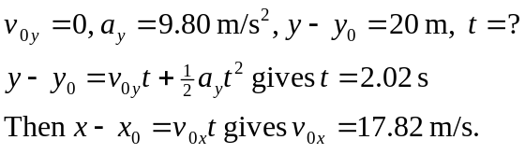
Use conservation of energy, where point 1 is at the starting point and point 2 is at the edge of the pit, where 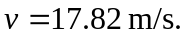Take  at point 2, so 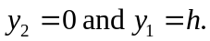
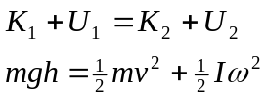
Rolling without slipping means 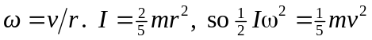
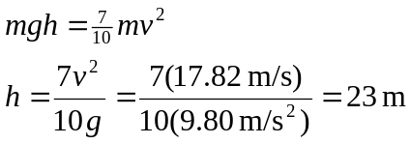
b) 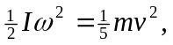 Independent of r.
c) All is the same, except there is no rotational kinetic energy term in 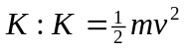
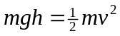
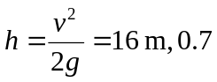times smaller than the answer in part ( a).

